**Database Systems Project 1 – CSE 5330-002**

**NAME:** Prathamesh Hemant Korale

**STUDENT ID:** 1002157955

**PROFESSOR NAME:** Ranjan Dash

**SEMESTER:** FALL 23

**OVERVIEW:**

To learn how to utilize a relational DBMS, information on the database system project was provided in this file. Tables are created, loaded with data, queried, and updated using the interactive command line facility and the SQL programming facility.

**STEPS FOR CONNECTING OMEGA SERVER**

* UTA Omega Sever Account Creation.
* Getting Access to MySQL Database.
* Username and Password are used to login for Omega in Command Prompt.
* To Connect to MySQL, the below command is used along with Database Password

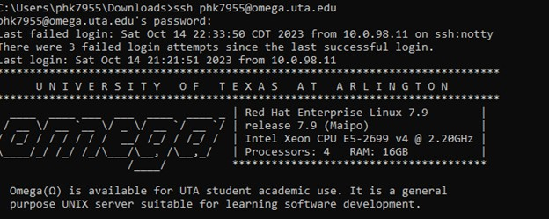



1. **Created Tables for World Cup SOCCER**

* To Create Table, the commands used in MySQL are stored in text file names as **Queries Q1.txt** in Problem 1 Folder.

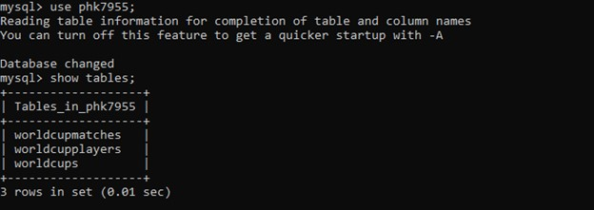

**2. Loading of DATA from CSV File Using Python (Version 2.7)**

* The Data was Load from CSV File Which Were Uploaded to Omega Server Using Following Commands.
* All Files Were Uploaded to Omega Server from where we inserted the data into the Tables Using Python Version 2.7 are stored in the Folder Problem 2 which contain all .csv and .py files.
* The Output Snapshots from the Omega Server are attached below.

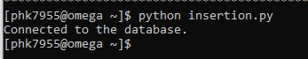

**3. QUERIES for the Questions Given**

* All Outputs of the Queries Questions including Output Were Stored in the folder Named Problem 3.
* The queries are executed from the Omega server's SQL command line.

**4. Insertion of 3 Records violating Integrity Constraints**

* Violation of Foreign Key Constraint, Primary Key Constraint and Check Constraint Queries are inserted in the file name of particular constraint and the output is stored in the snapshot form.
* The Queries are executed from the MySQL command line in the Omega Server.

**5. Deletion of records violating Referential Integrity Constraints**

* The Project Folder Contain the Folder with Name Problem 5.
* It contains a file containing a query for Deletion of Records Violating Referential Integrity Constraints.
* The Queries are executed from the MySQL command line in the Omega Server.
* The Output is stored in form of snapshot.

**6. Insertion of 3 records that does not violate any Integrity Constraints**

* The Project Folder Contain the Folder with Name Problem 5.
* It containing file containing queries for the Insertion of records that does not violate any Constraints.
* The Queries are executed from the MySQL command line in the Omega Server.
* The Output is stored in form of snapshot.

**Notes:**

* DateTime are inserted as VARCHAR cause DateTime Datatype was giving error while inserting.
* MySQL Command Line Does Not Support Spool Files as it is a Functionality of MySQL*PLUS.
* Round ID is Not set as Primary Key as it is having Lots of Duplicate data.